**Pyber Ride Sharing Analysis**

1. The below plot shows the average relationship between average fare and total number of ride per city
2. Average fare looks higher for rural cities followed by sub-urban cities and then Urban cities.
3. On Average it looks that total number of rides are higher for urban cities followed by Suburban and then rural cities.
4. The above two points indicate some sort of pricing economics for Pyber that might include lower pricing in urban areas compared to rural areas.

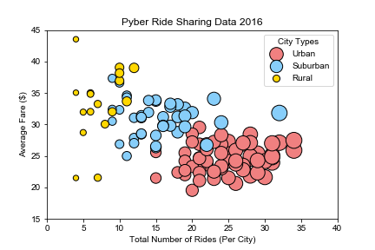

1. The below chart shows that more than 60% of Pyber’s revenue is coming from Urban areas.

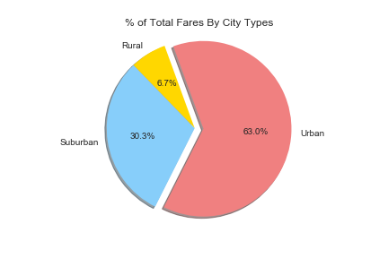

1. The below chart shows that more than 68% of Pyber’s total rides were in Urban cities.

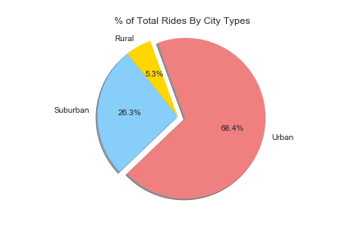

1. The below chart shows that more than 86% of Pyber’s drivers were in Urban cities, which could also be a reason for higher revenue contribution from Urban areas.

